1. **Agenda**:
   1. We will implement Runnable interface using the
      1. **Legacy Way**: Using anonymous classes.
      2. **Modern Java way**: Using lambda
   2. Then we will compare both and discuss the advantages of one over the other.
2. 
3. 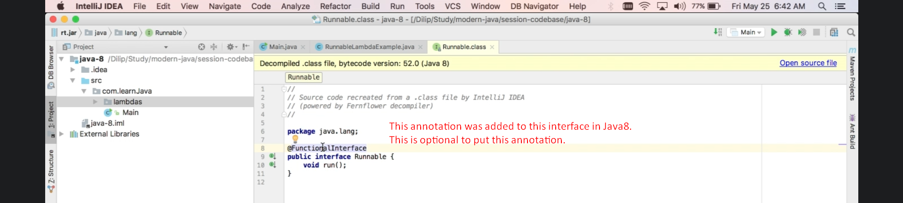
4. 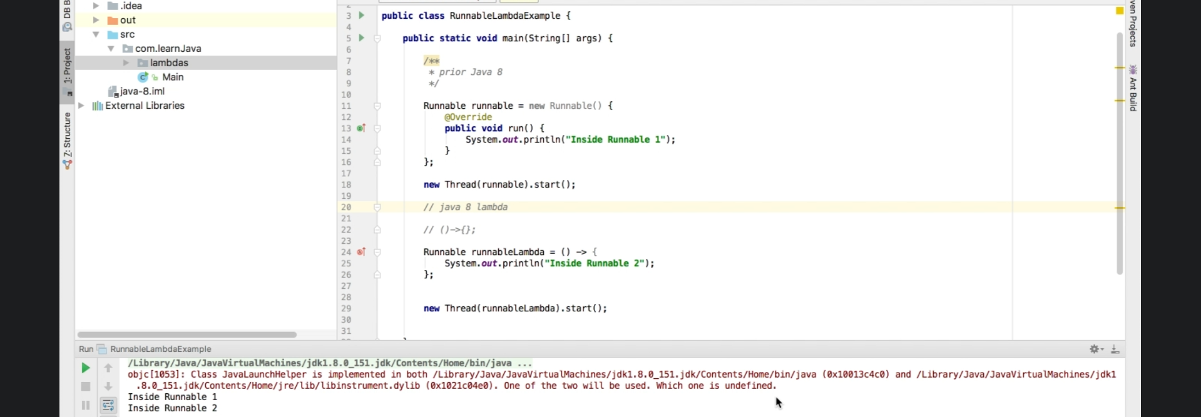
   1. **Differences**:
      1. Lot of boiler plate code in anonymous class.
      2. Lambda is concise, looks very simple.
5. 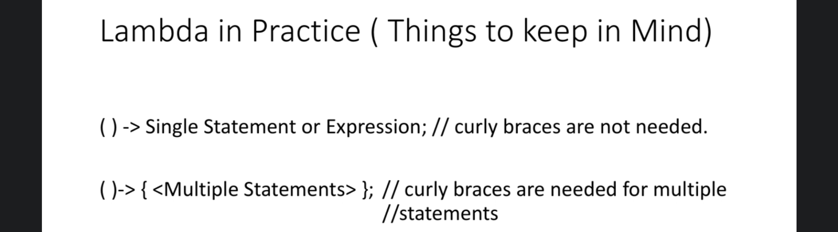
6. 